

A REVISED EDITION

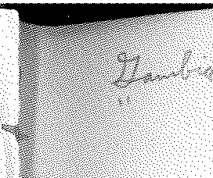

OF THE

# ORDINANCES

OF THE

# COLONY OF THE GAMBIA

INCLUDING

## GOVERNOR'S ORDERS AND PROCLAMATIONS, ORDERS-IN­ COUNCIL, AND RULES AND REGULATIONS MADE UNDER ORDINANCES ; LETTERS PATENT AND STANDING ORDERS OF LEGISLATIVE COUNCIL ; ORDERS OF THE KING IN COUNCIL ; AN INDEX AND APPENDICES .

PREPARED UNDER 'rHE AUTHORITY OF

## THE REVISED EDITIO N OF THE LAWS ORDINA NCE, 1938,

BY

JOHN MILNER GRAY, M. A.,

( OF GRAY'S IN N, BARRISTER·AT-LAW ) ;

*Jud g e of the Supreme Court of the Colony of the Gambia.*

IN THREE VOLUMES:

VOI.1. II

CONTAINING THZ OlllJINANCEFCHAP!f.RS 83-153.

' ' " '

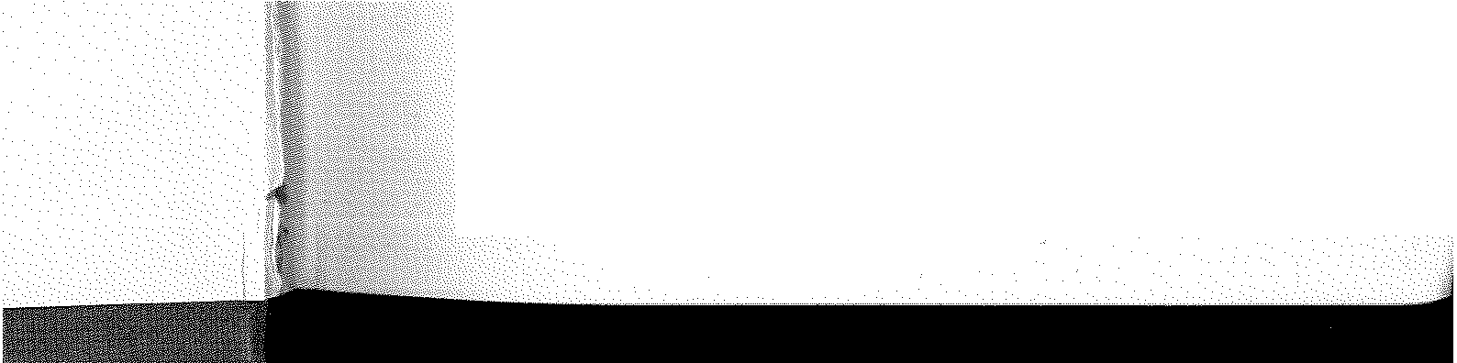

PUBLISHED FOR THE GOVE;,11jEJlT OF TH:l COLON)' OF 7HE GAMBIA.

PRINTED BY

J. A. GEORGE, GOVERNMENT PRINTER, BATHURST, GAMBIA

1942.

1248 *1'<(wn of Bathurst.*

**[CAP, 137, *0***

Beating drnms, &c., without permission, unlawf ul.

Warning to be given by constable.

Refu&al to desist.

Penalty.

pffence is committed, or by his servant, or by any person authorised by him, and may be detained until he can be delivered into the custody of a constable, who 11hall take such person as soon as con­ venien tly may be before the Court to be dealt with according to law.

UNLA'-YFUL DRUMMING, &c.

19.-(i) *N o* person or persons, without the perm1ss1on in writing of the Governor or the Superintendent of Police, shall assemble or be in any street, house, building, garden, yard or other plare beating any drum , gong, tomtom or other instrument, or dancing or making any unnecessary noise to the disturbance or annoyance of the neighbours.

(ii) Any constable, by himself or with such assistance as he may take to his aid , may warn the persons so unlawf ully assembled to depart, and f or this purpose may enter into such house, build­ ing, garden , yard or place in which persons ar.e so assembled.

1. ,vhosoever, af ter being warned, as provided by section 19 h ereof , shall not depart forthwith, except the persons actually dwelling in such house or building, may be apprehend ed without warrant by any constable or person acting in his aid , and shall be liable on conviction to a penalty not exceeding ten shillings.

ha th ex a pe be *of*

cl<

### m

Vl

at or

OU

### pe be of fr th

Liability

1. The occupier of any house, building, garden, yard or a,

of occupier ef house, &c.

place who shall have permitted such persons unlawfully to assemble 0£ or be therein against the provisions hereof shall be liable on con­ or viction to a penalty not exceeding f orty shillings, and every drum, re

gong, tomtom or other such instrument found on the premises n(



Court may prohibit drumming, &c., during its sitting.

Power to impound stray cattle.

shall be liable to forf eiture.

**22,** Any Coµrt may prohibit during the hours of its sittin,s, and at any place within a radius of three hundred yards from tha building where such sitting is held, any beating of drums, gongs, tomtoms or other instruments or other loud noises of any kind or description ; and any person who, on being required by any con­ stable or officer of the Court to desist from beating drums, gongs, tomtoms or ether instruments, or from making any other such noise, f ailii to comply with such requisition, shall for every off ence be liablo on conviction to a penalty not exceeding forty shillings, and may be apprehended by any constable without warrant.

STRAY CATTLE.

**23,-(i)** If any cattle are found at large in any street without any person having charge thereof , any constable or person assist­ ing him, or if any cattle shall be found trespassing on any en­ closed S"'ound or lot, the owner thereof or anyone acting 011 his be-

al

th

0

* i

### 111